Task Description:

Launch jenkins and explore creating projects and users.

AWS – Instance creation is done.
Added TCP -8080 port inbound rules in security code.
Java installed.
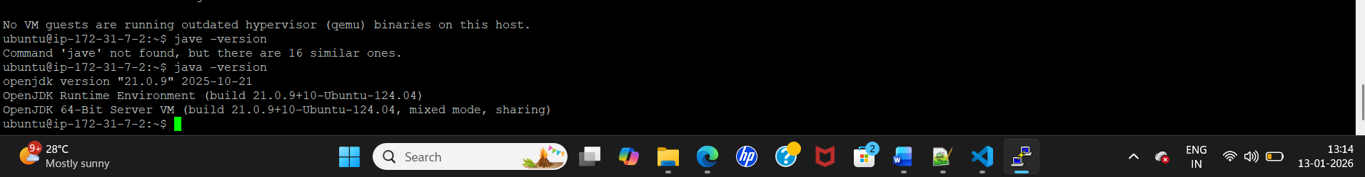

Jenkins set up done:
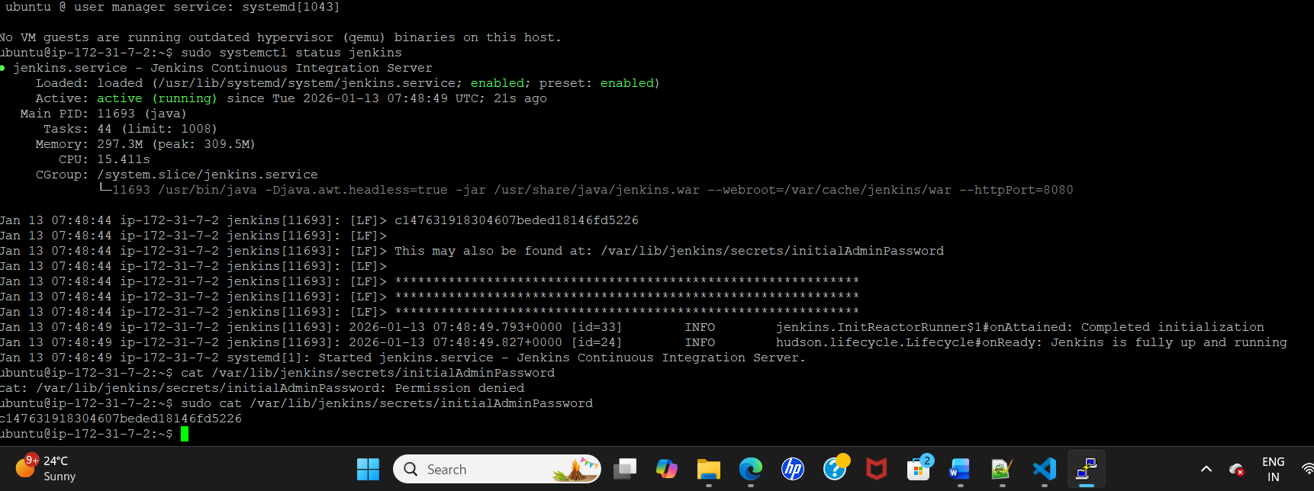

Jenkins URL:
http://13.233.68.187:8080/

Freestyle Project:

1.Job creating for below and doing manual trigger
- Build
- Test
- Deploy
Screenshot:
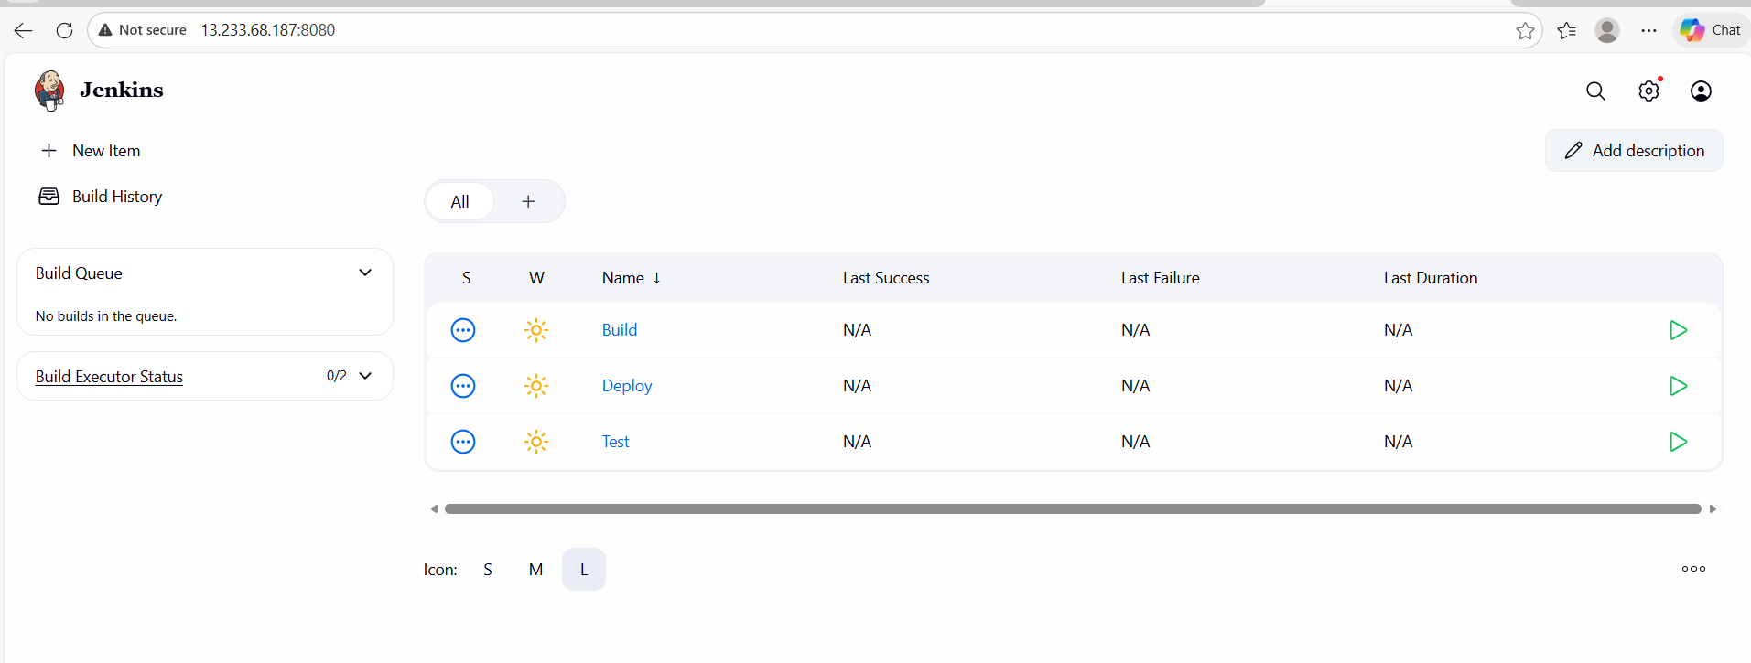
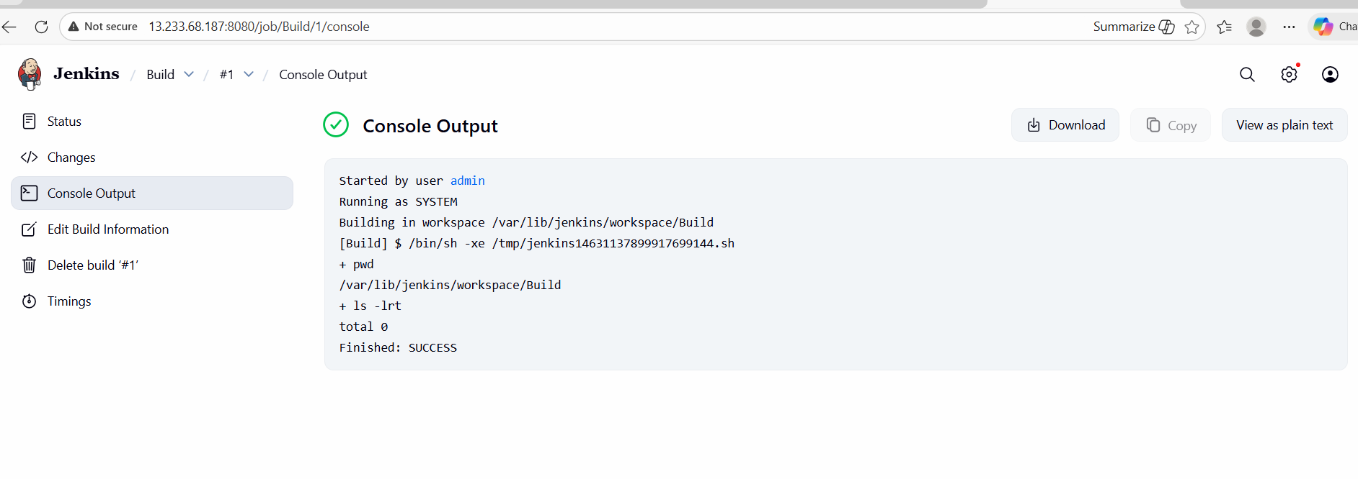
2.
JOBS ORDERING:
1. we need to order all the projects, so that once the projects got triggered all the projects related to this should get executed automatically.
2. go inside the BuildProject - configure - Post-Build Actions - add post-build actions - select (build other projects) - type (TestProject,) - save.
click back to dashboard
3. same way, go inside TestProject - configure - Post-Build Actions - add post-build actions - select (build other projects) - type (DeployProject,) - save.
click back to dashboard
4. now run the BuildProject - on the left-hand side you can see the Build Queue (Testproject & DeployProject will get executed) once done we will get the msg like No builds in the queue, now try to refresh the page, we will be able to see all the projects got executed in order wise and the number of attempts changes to (2)
5. Now we are doing to trigger manually, but how to do this periodically == to do that click on (BuildProject) - configure - build triggers - enable the build periodically check box - now schedule the time (* * * * *) [ this is going to schedule it for every minute]
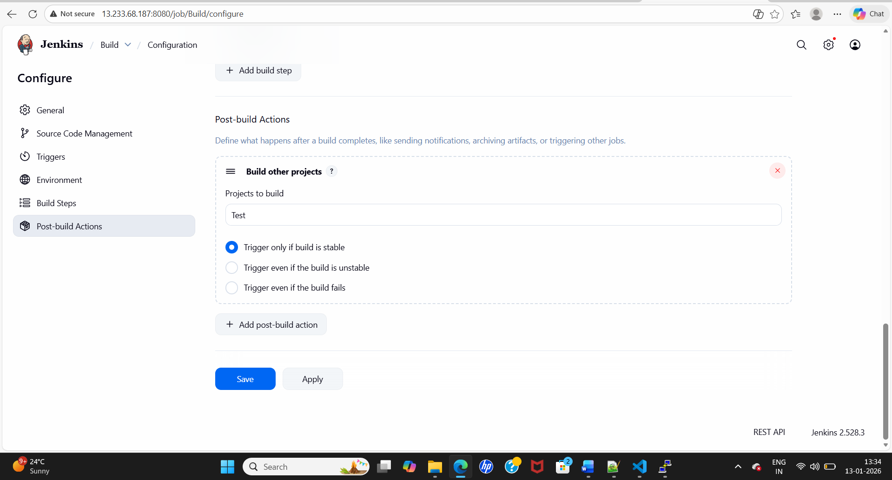
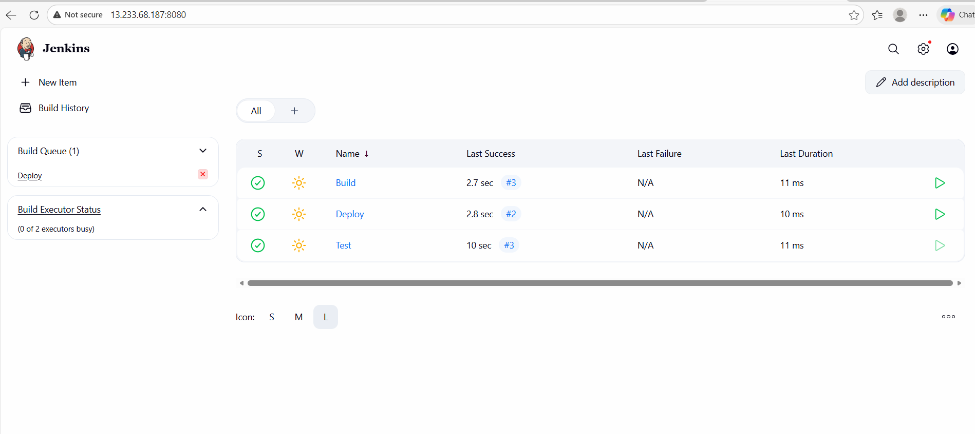
3.Scheduling and auto trigger.

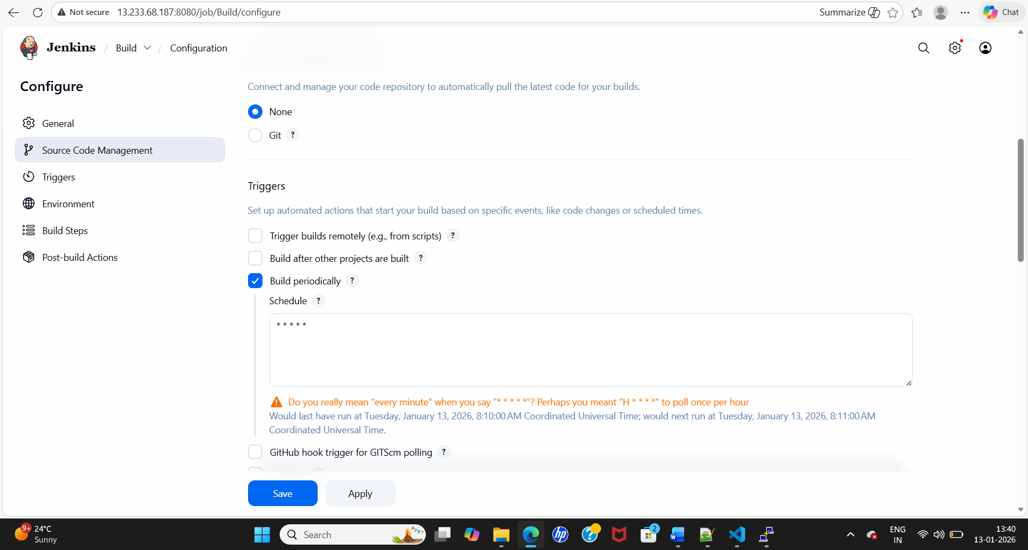

Pipeline script:
1.Jenkins launch via docker desktop.
2.Pipeline script.
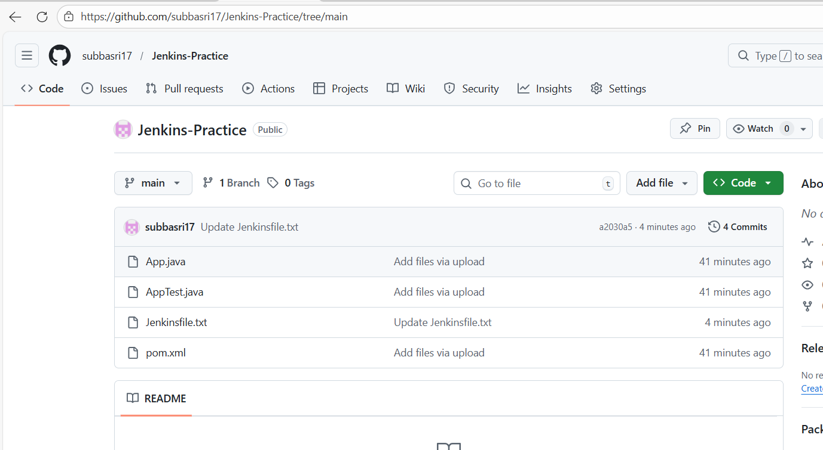
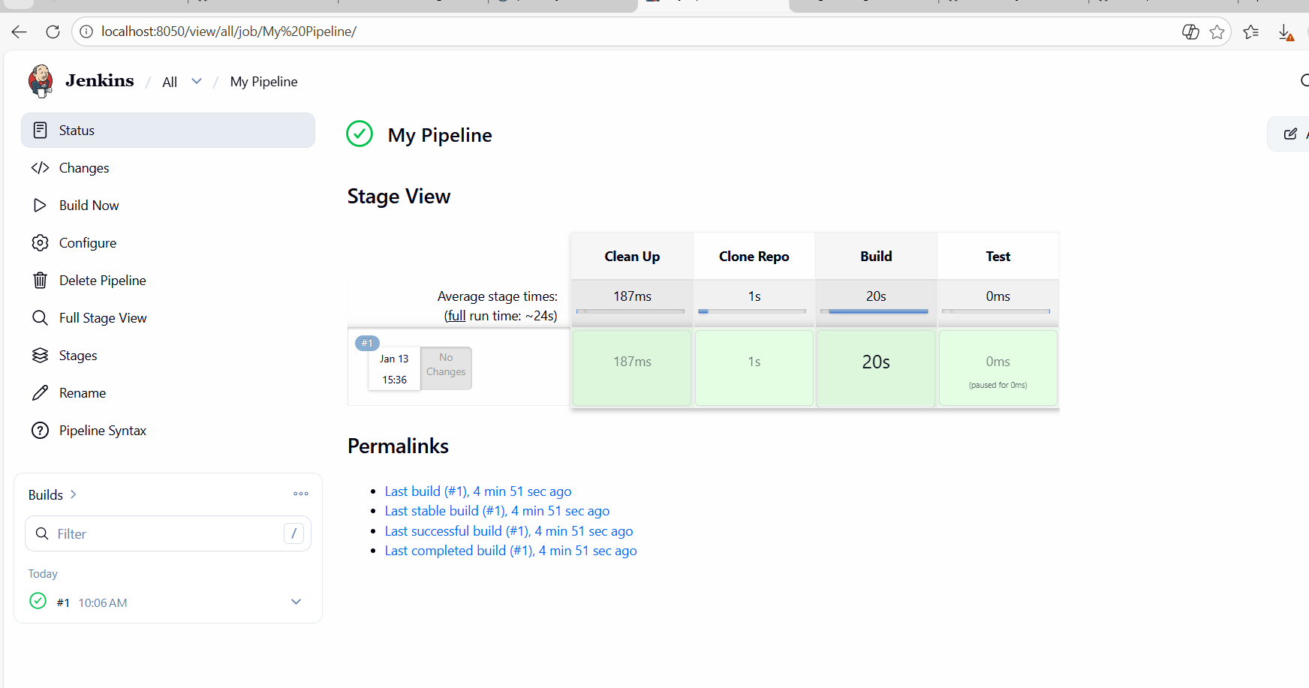
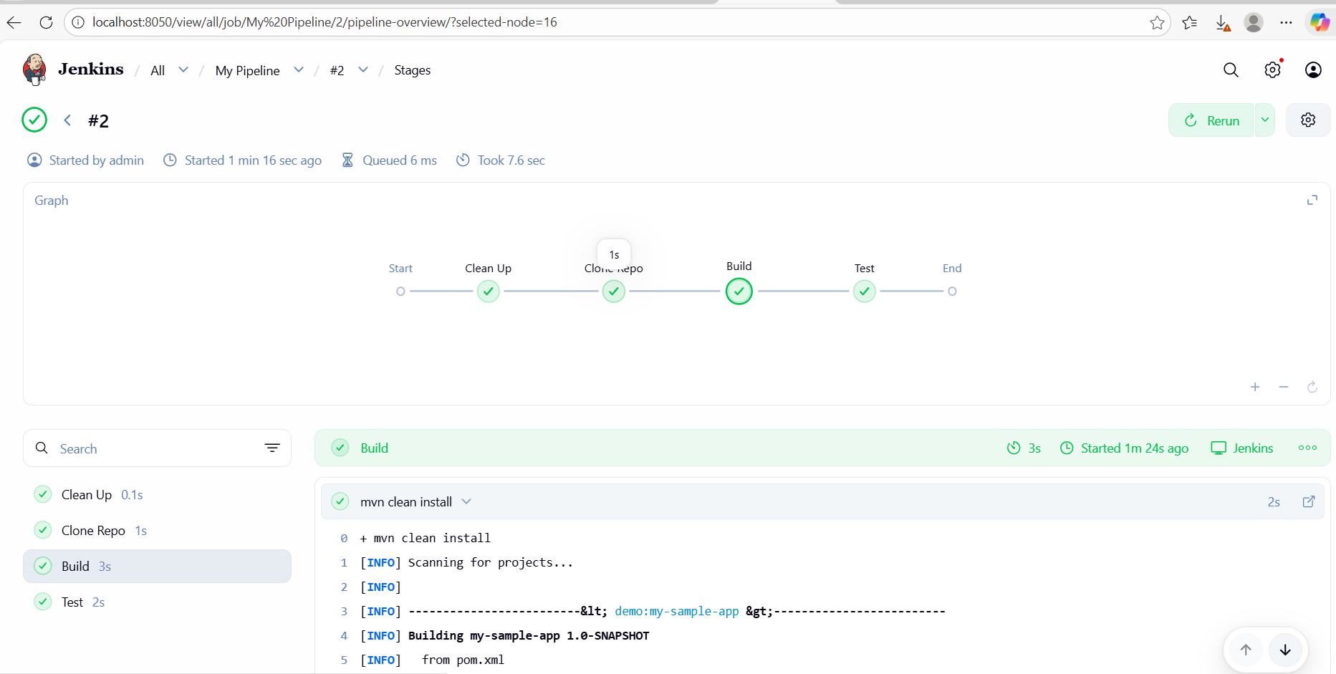
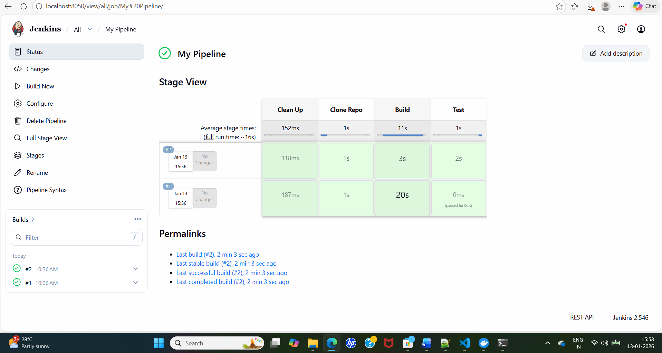

Output:
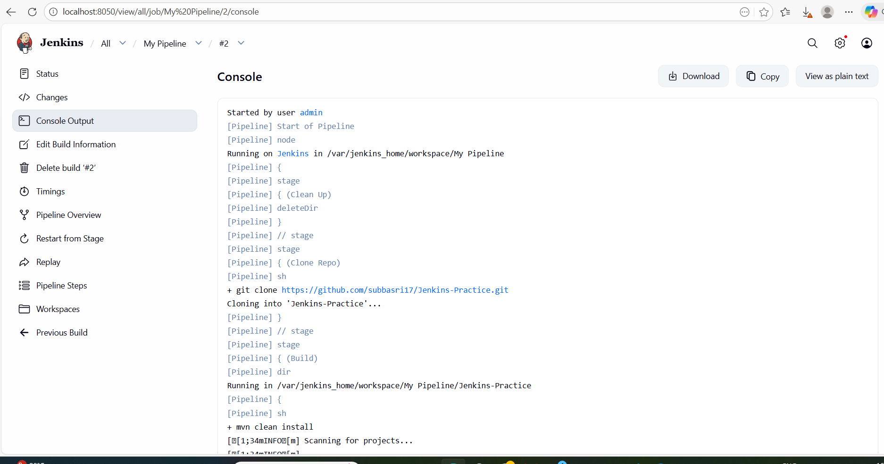
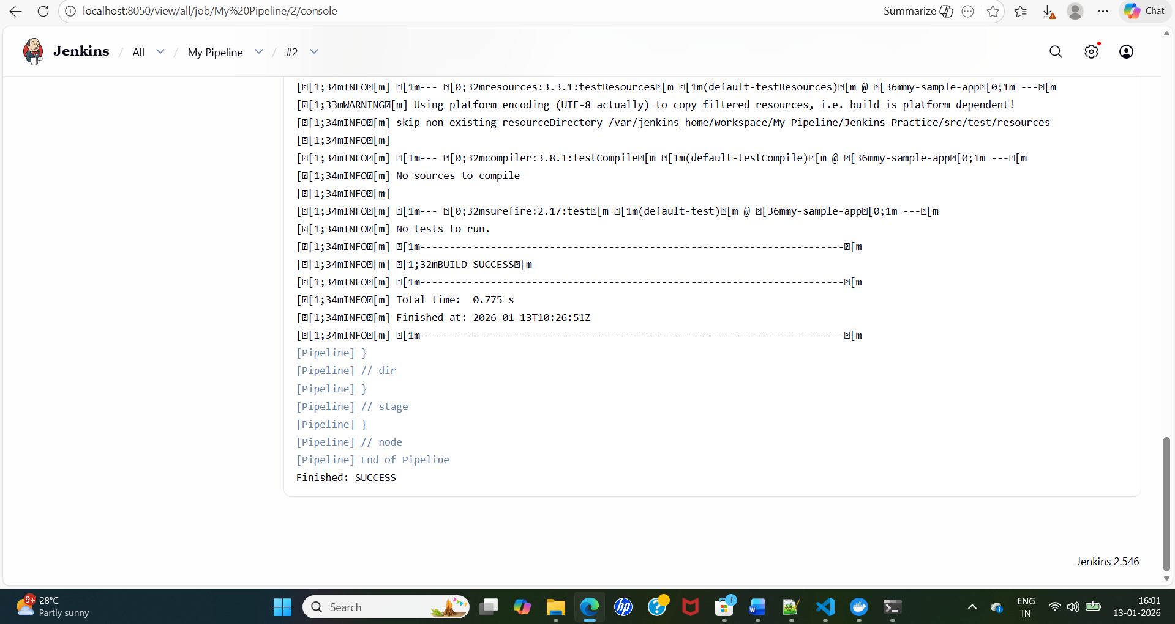
.

Multi-Branch Pipeline:
Github:
3 branches:
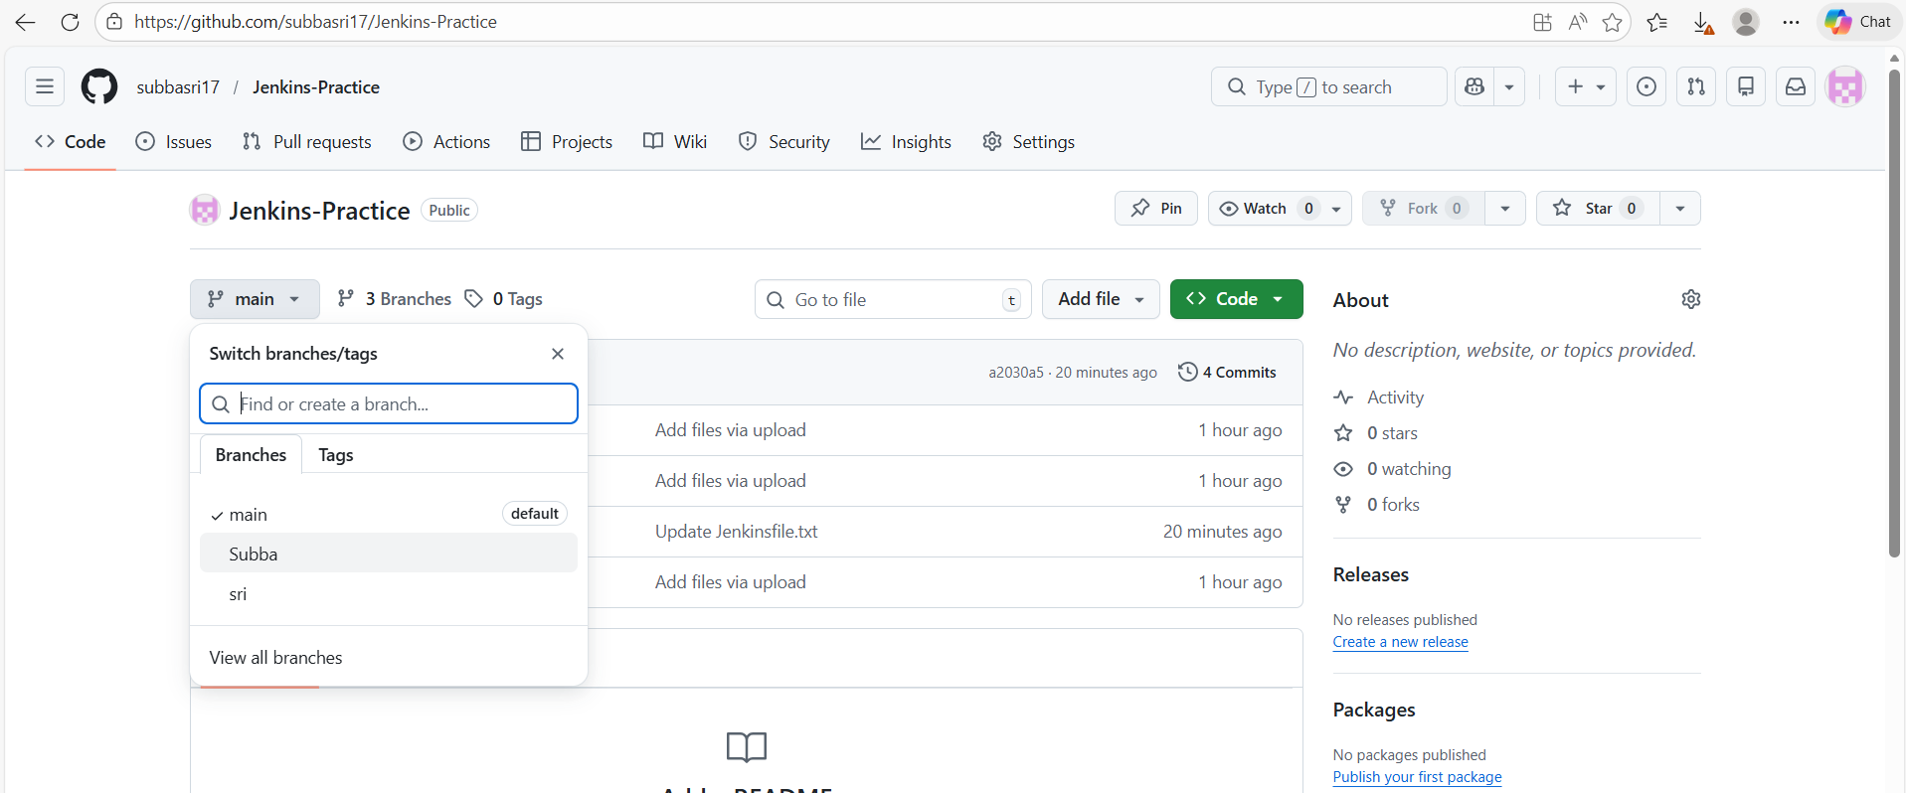

Created multibranch pipeline script and executed;
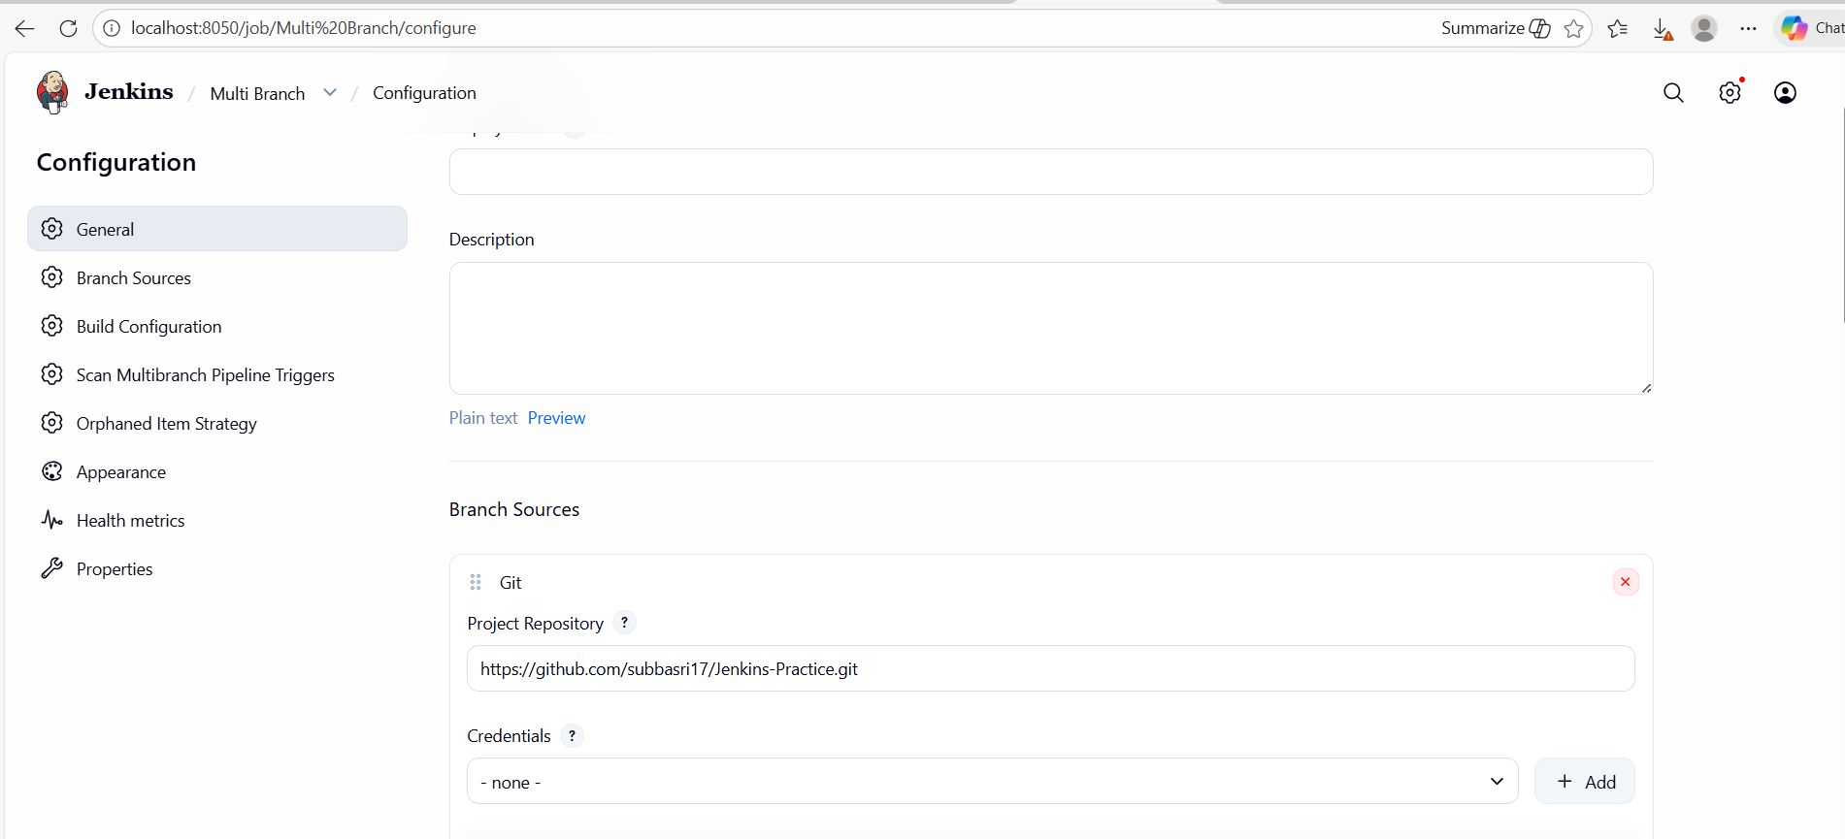
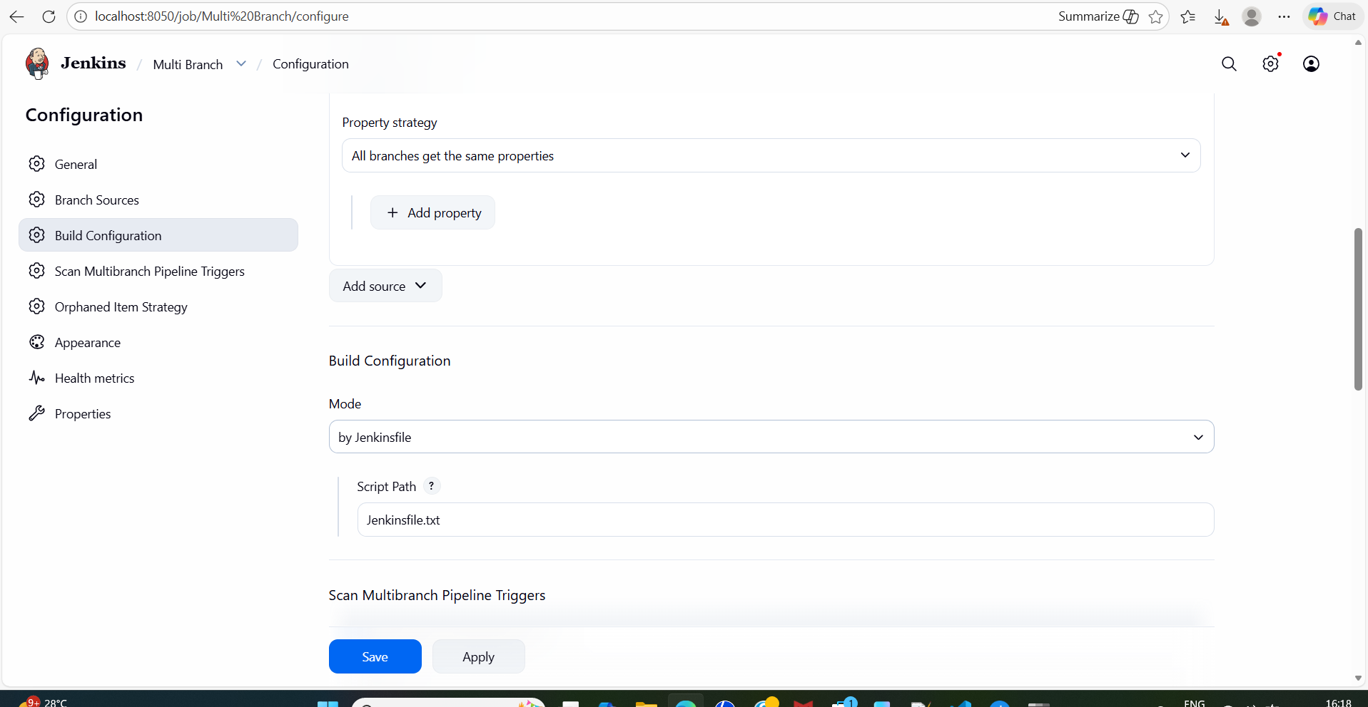
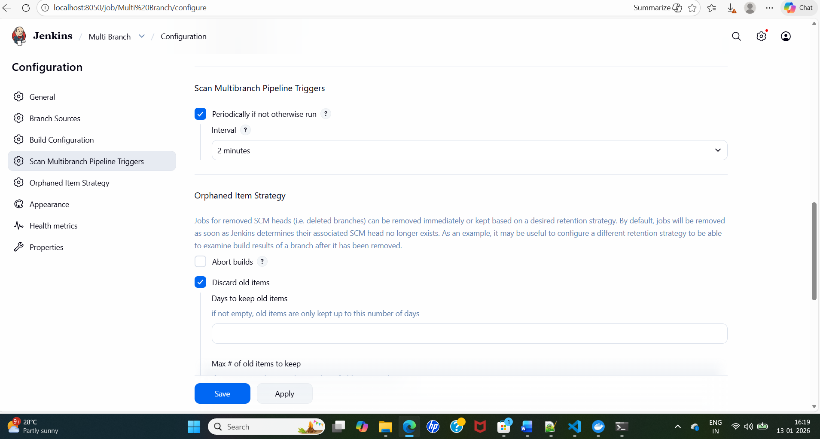
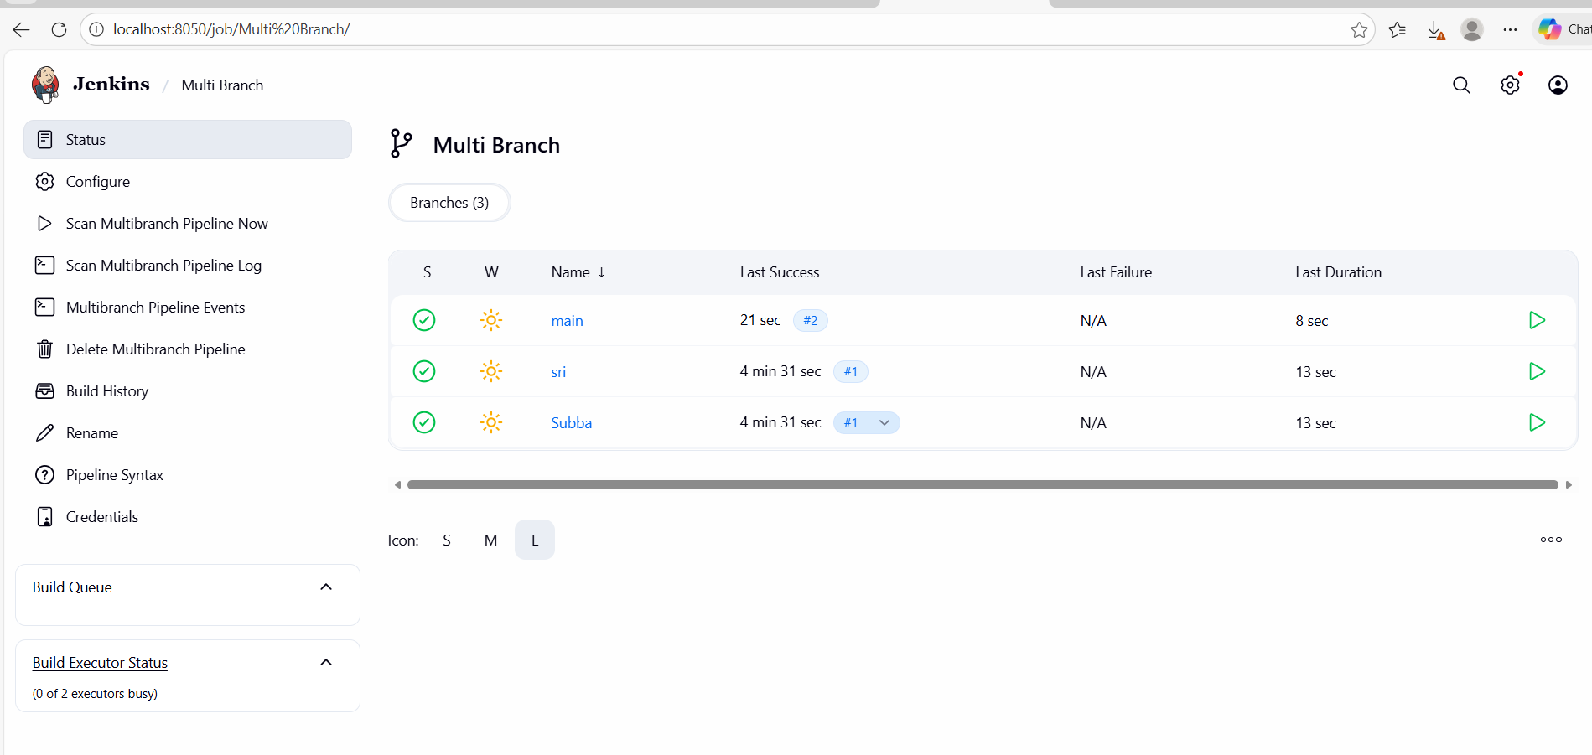
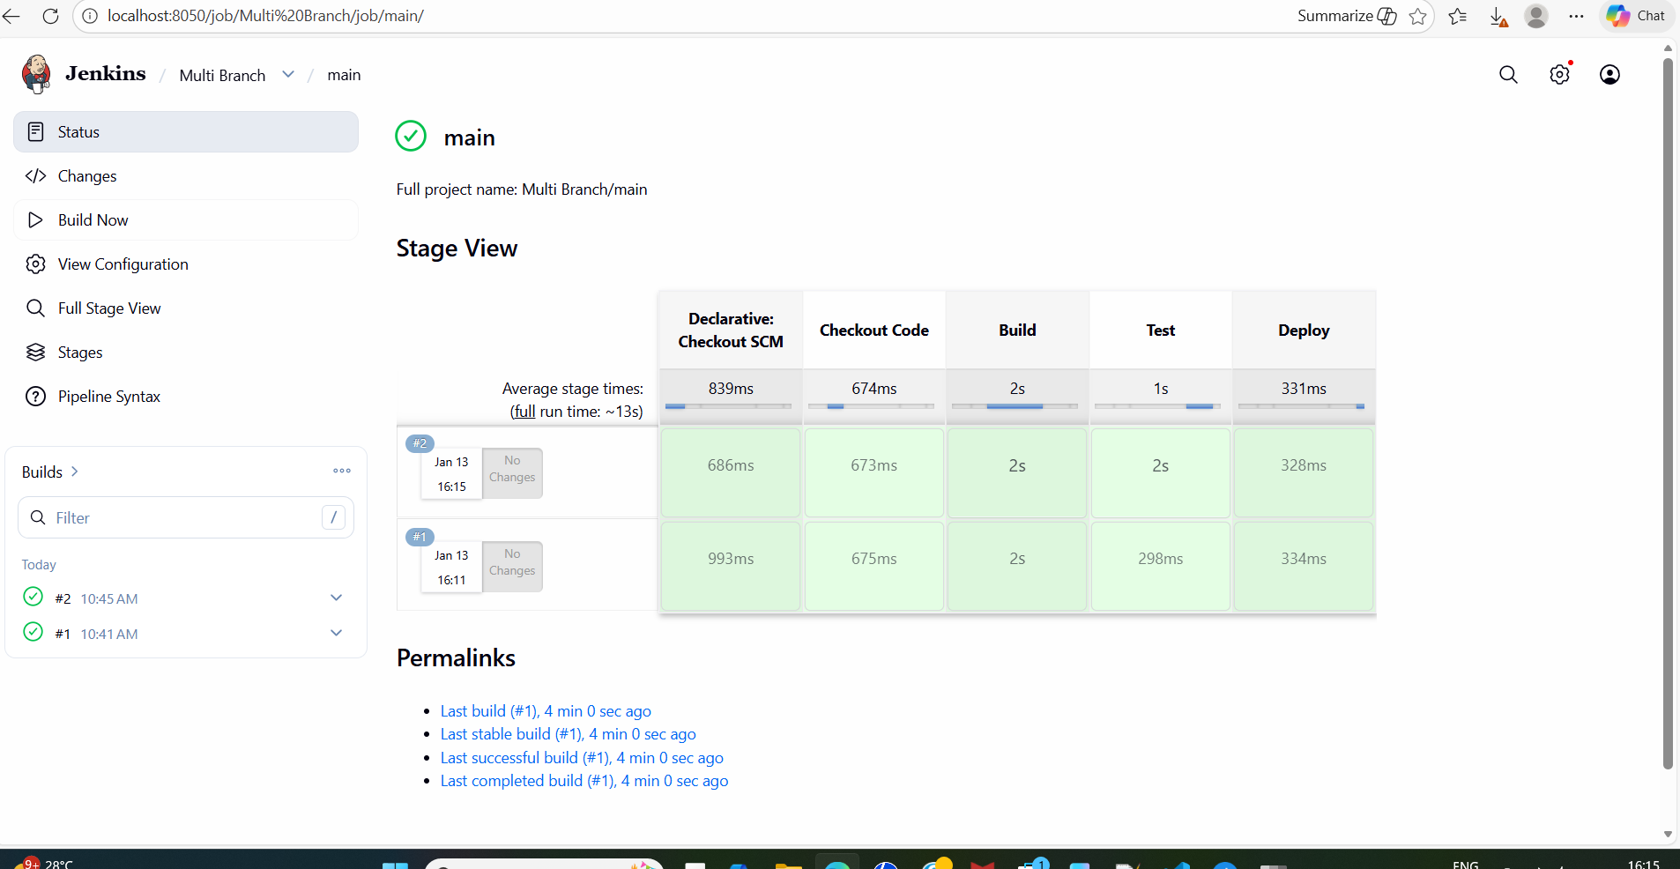
Console output:
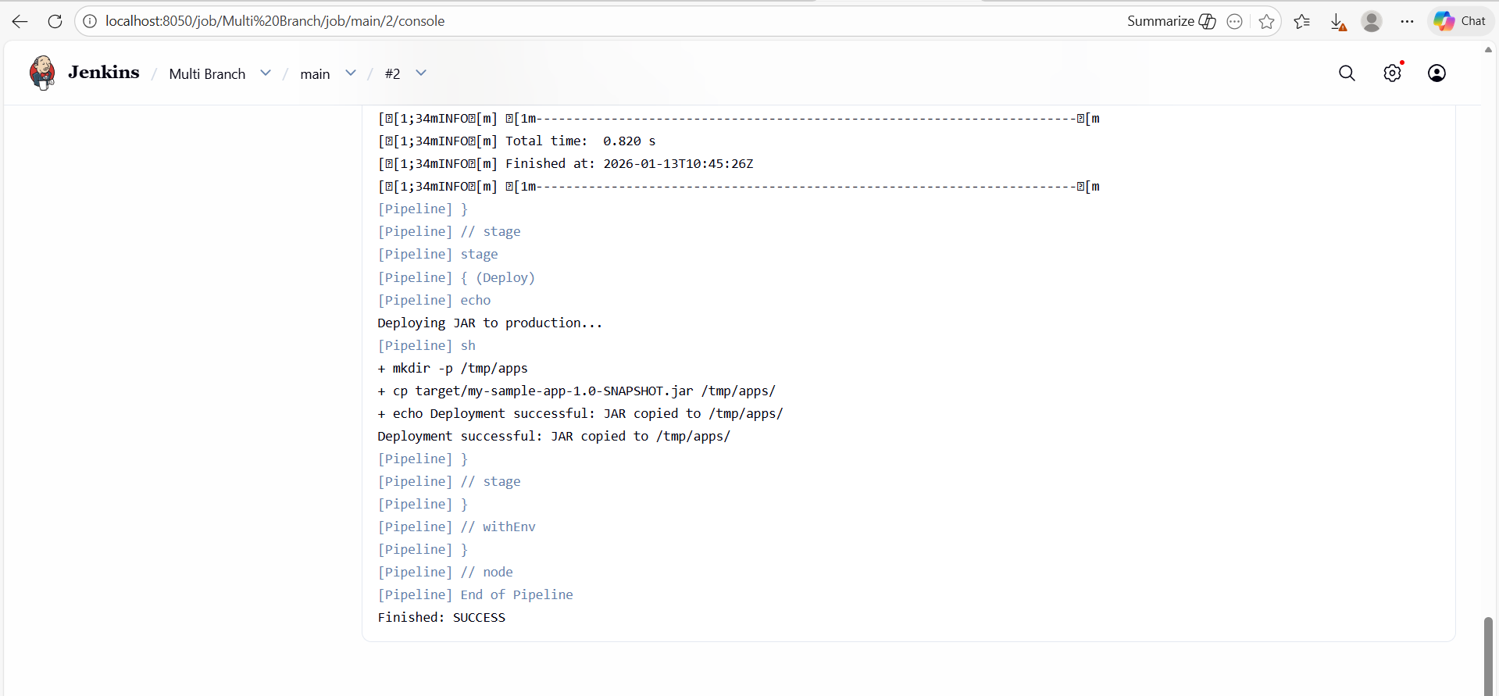

Started by timer
[Tue Jan 13 10:51:02 UTC 2026] Starting branch indexing...
> git --version # timeout=10
> git --version # 'git version 2.47.3'
> git ls-remote --symref -- https://github.com/subbasri17/Jenkins-Practice.git # timeout=10
> git rev-parse --resolve-git-dir /var/jenkins_home/caches/git-e2a985df8f3f5d723a1aaebf57886cb6/.git # timeout=10
Setting origin to https://github.com/subbasri17/Jenkins-Practice.git
> git config remote.origin.url https://github.com/subbasri17/Jenkins-Practice.git # timeout=10
Fetching & pruning origin...
Listing remote references...
> git config --get remote.origin.url # timeout=10
> git --version # timeout=10
> git --version # 'git version 2.47.3'
> git ls-remote -h -- https://github.com/subbasri17/Jenkins-Practice.git # timeout=10
Fetching upstream changes from origin
> git config --get remote.origin.url # timeout=10
> git fetch --no-tags --force --progress --prune -- origin +refs/heads/*:refs/remotes/origin/* # timeout=10
Checking branches...
Checking branch main
‘Jenkinsfile.txt’ found
Met criteria
No changes detected: main (still at a2030a5e7e6d9efcd1fcf98c5c5aa8b51b6db3a1)
Checking branch sri
‘Jenkinsfile.txt’ found
Met criteria
No changes detected: sri (still at a2030a5e7e6d9efcd1fcf98c5c5aa8b51b6db3a1)
Checking branch Subba
‘Jenkinsfile.txt’ found
Met criteria
No changes detected: Subba (still at a2030a5e7e6d9efcd1fcf98c5c5aa8b51b6db3a1)
Processed 3 branches
[Tue Jan 13 10:51:04 UTC 2026] Finished branch indexing. Indexing took 2.1 sec
Finished: SUCCESS

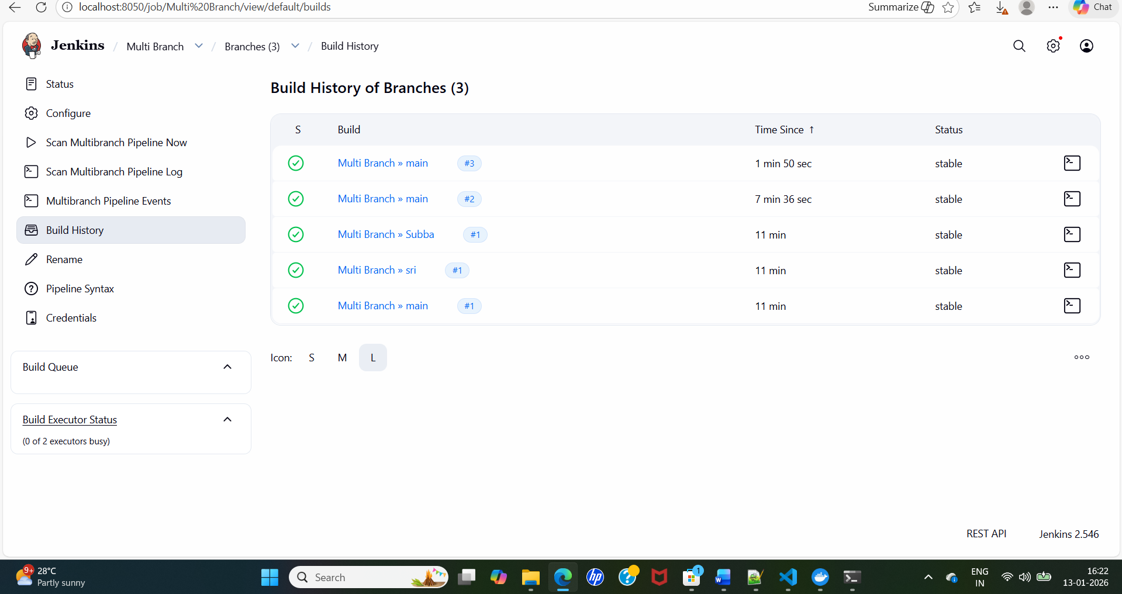

RBAC :
Enabling admin :
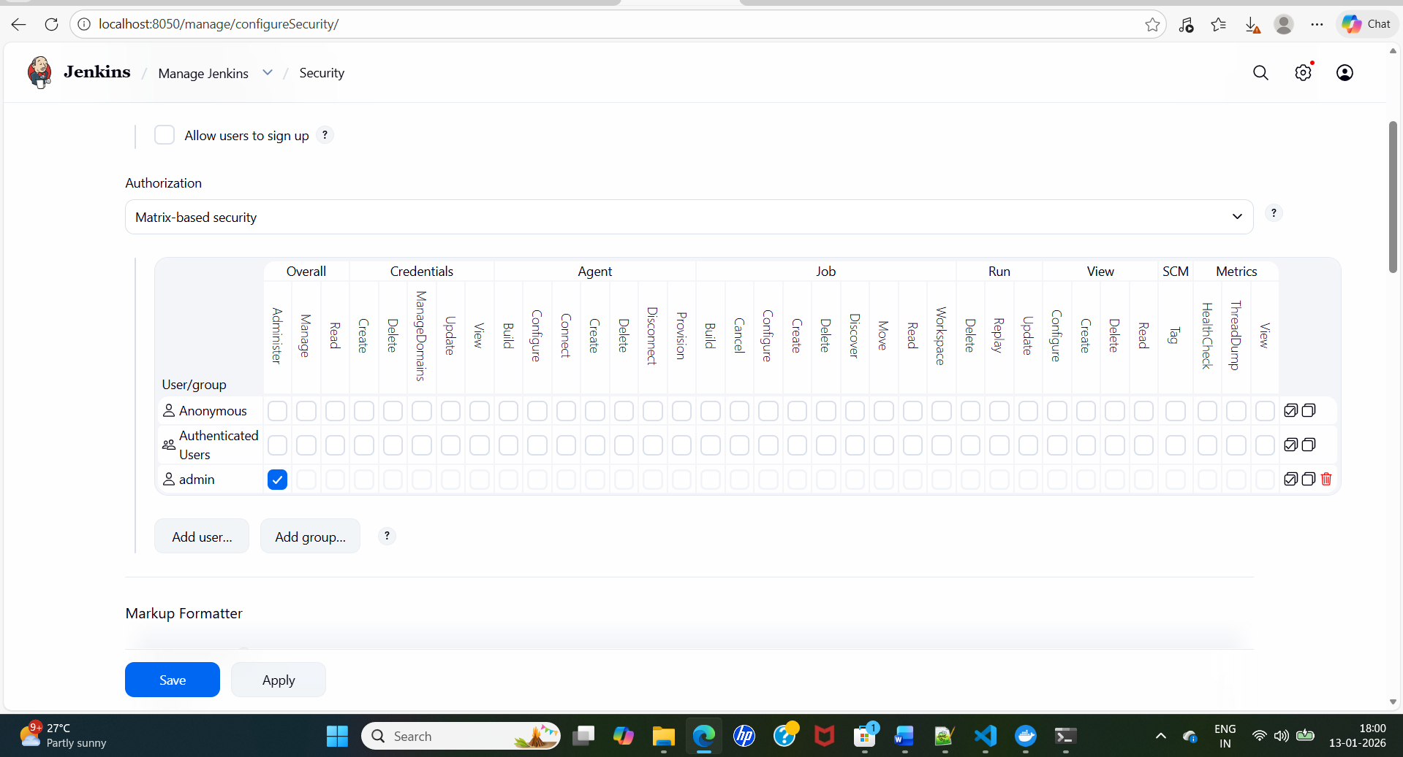

2.Create a users:
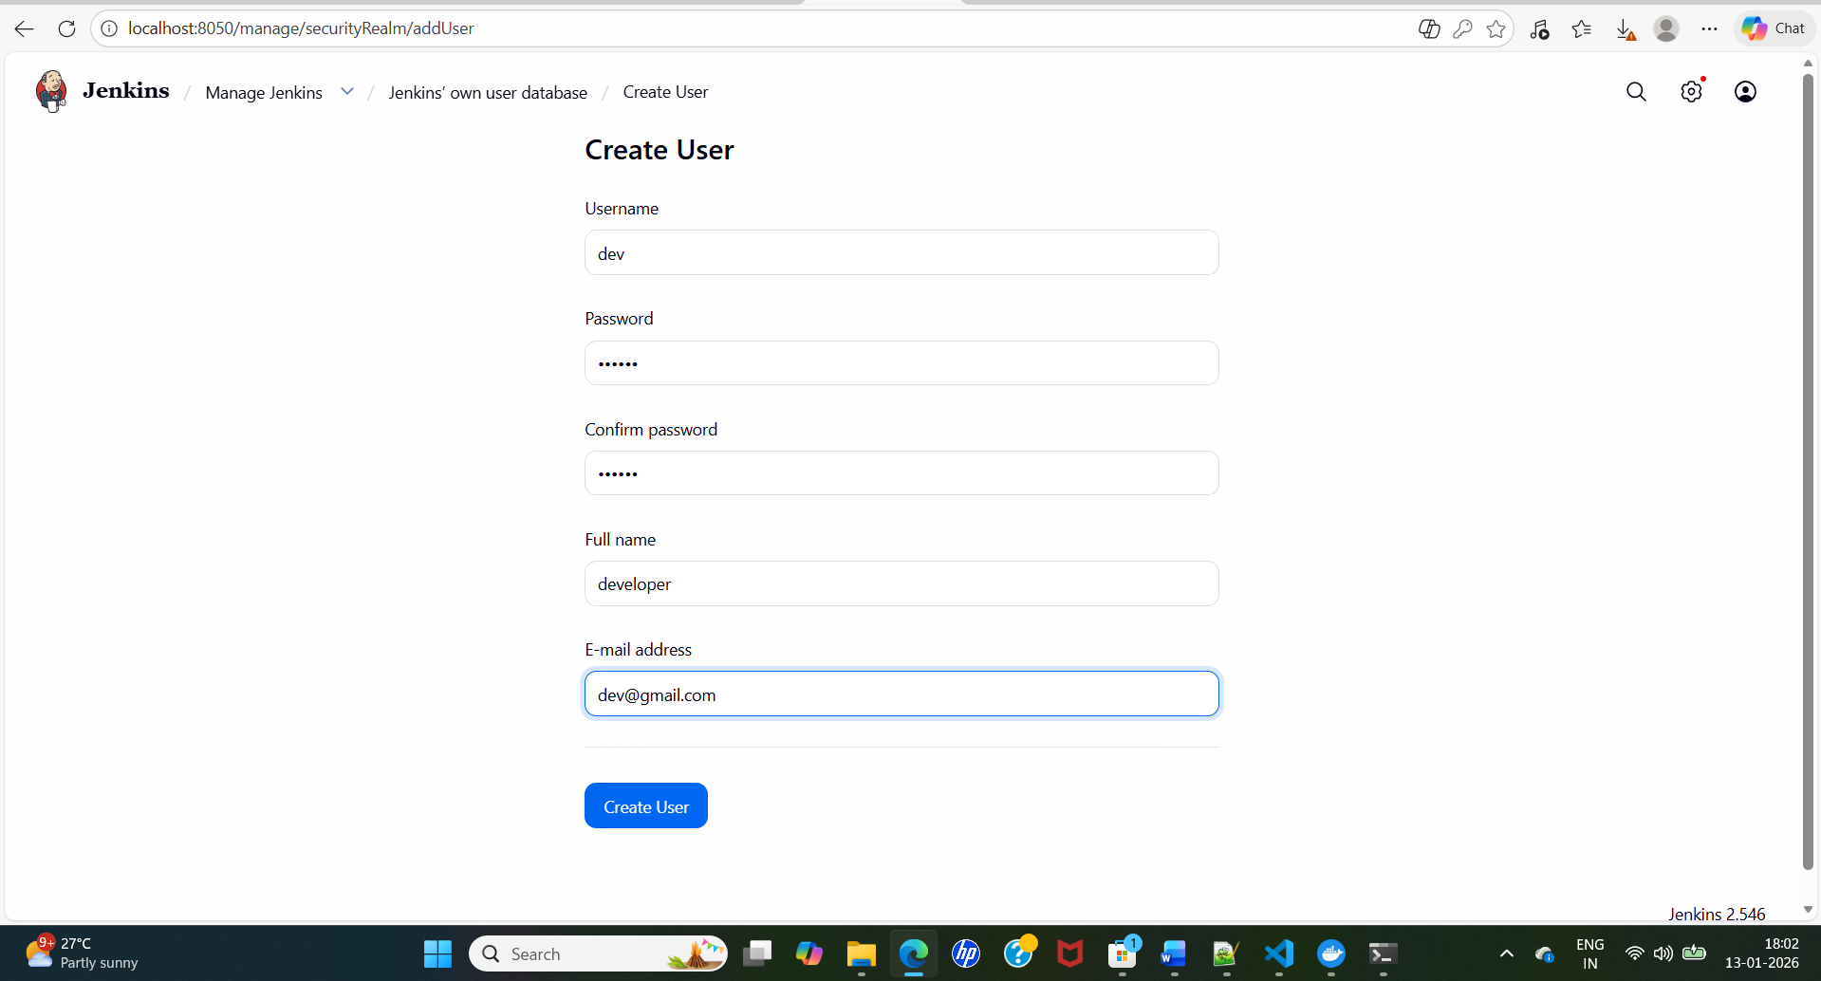
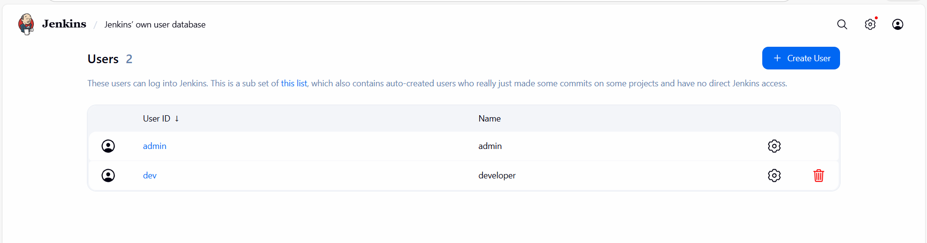
After installed role based strategy plugin, choose the same under security by creating permissions.
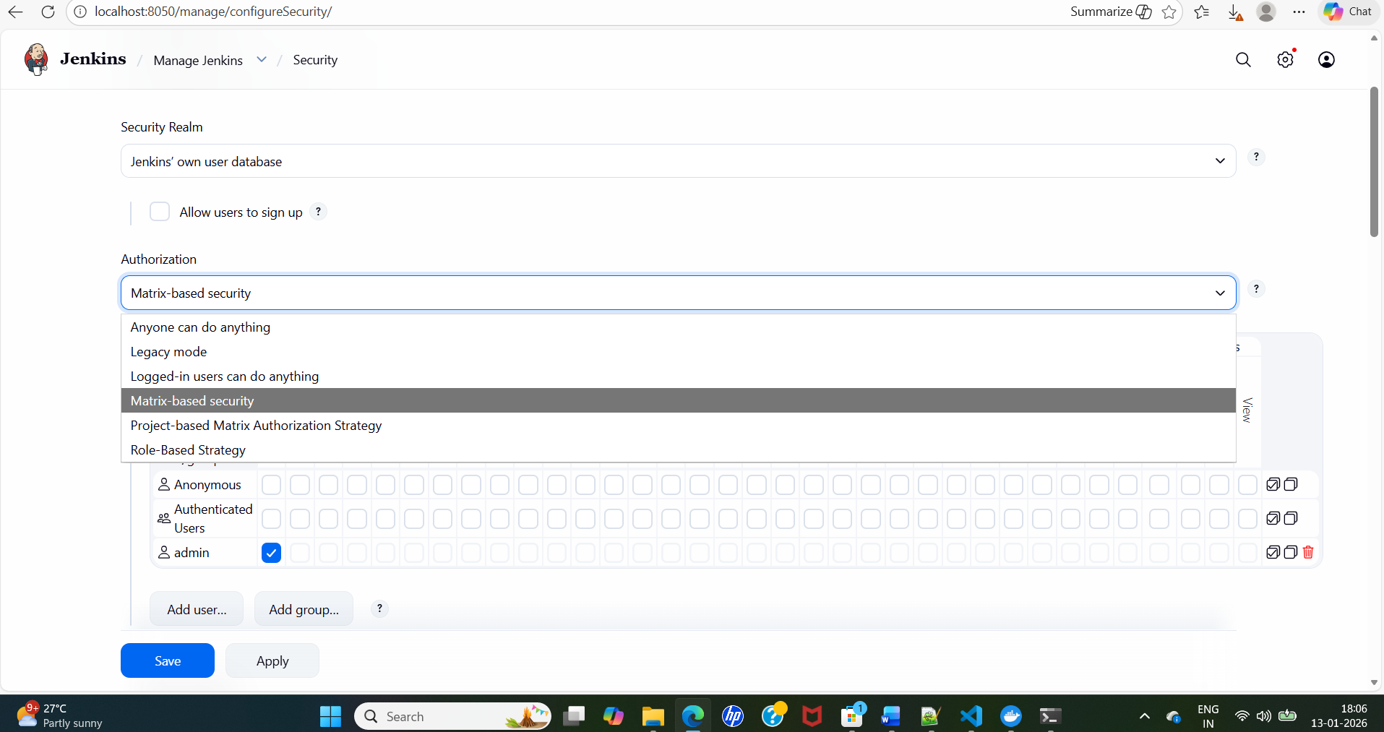

Earlier the highlighted one was not there, but later role based access created, manage and assign roles are appearing.

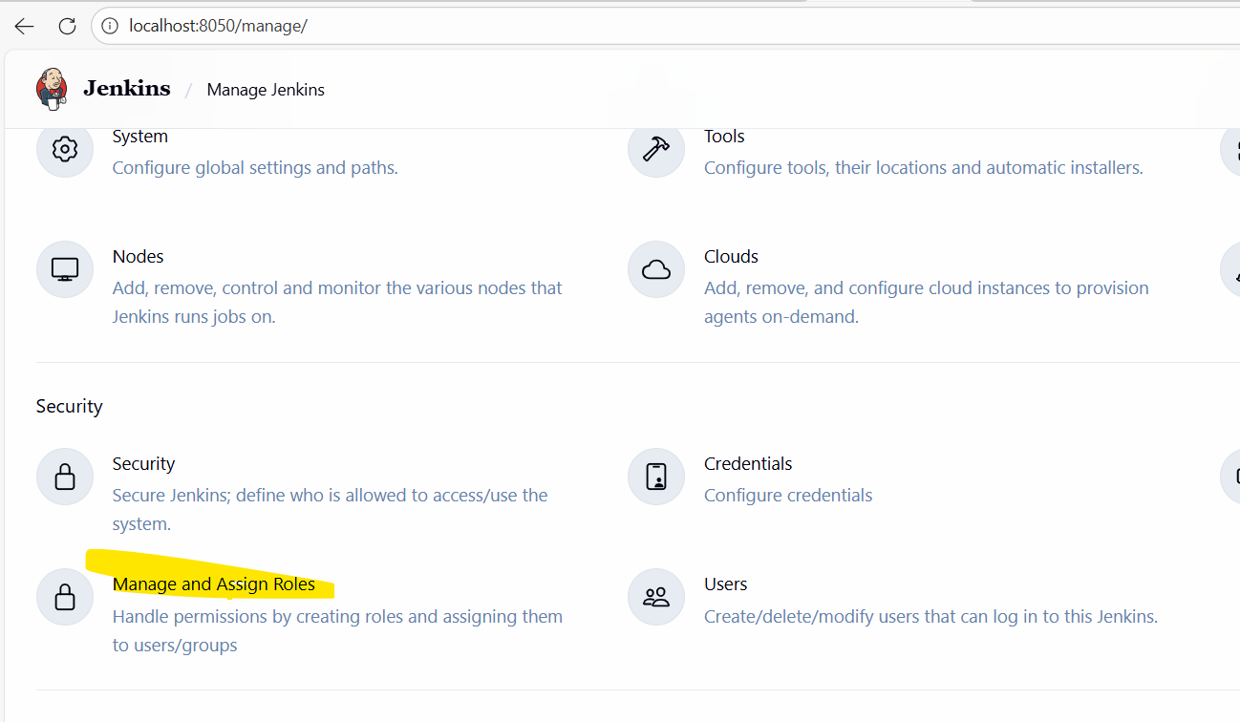
Created a dev group and the permissions attached to the group.
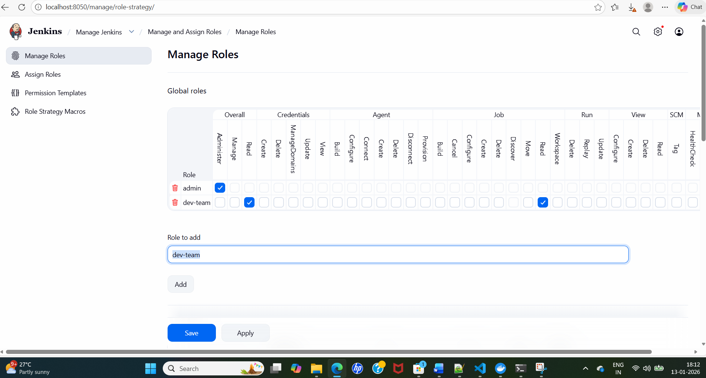
Now I need to add the user in that group.

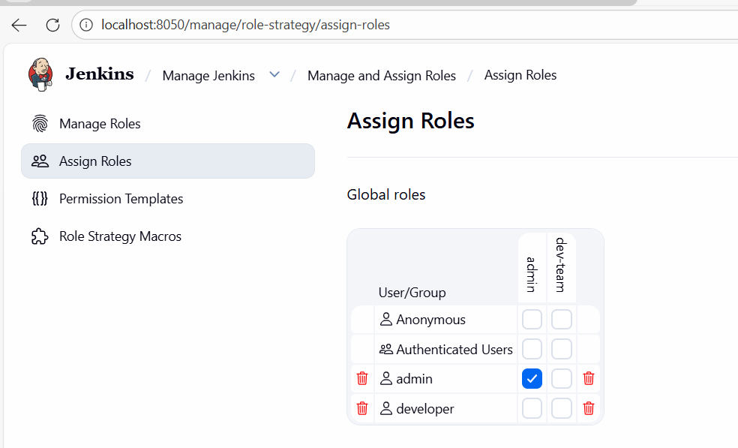
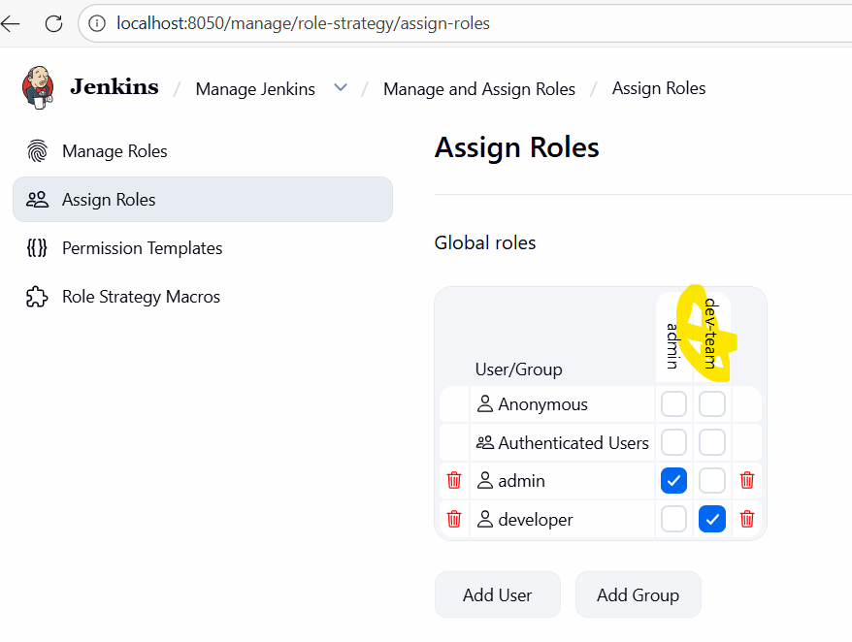

Switched into dev user:

I cant delete, or build. Just view and read the sample job.

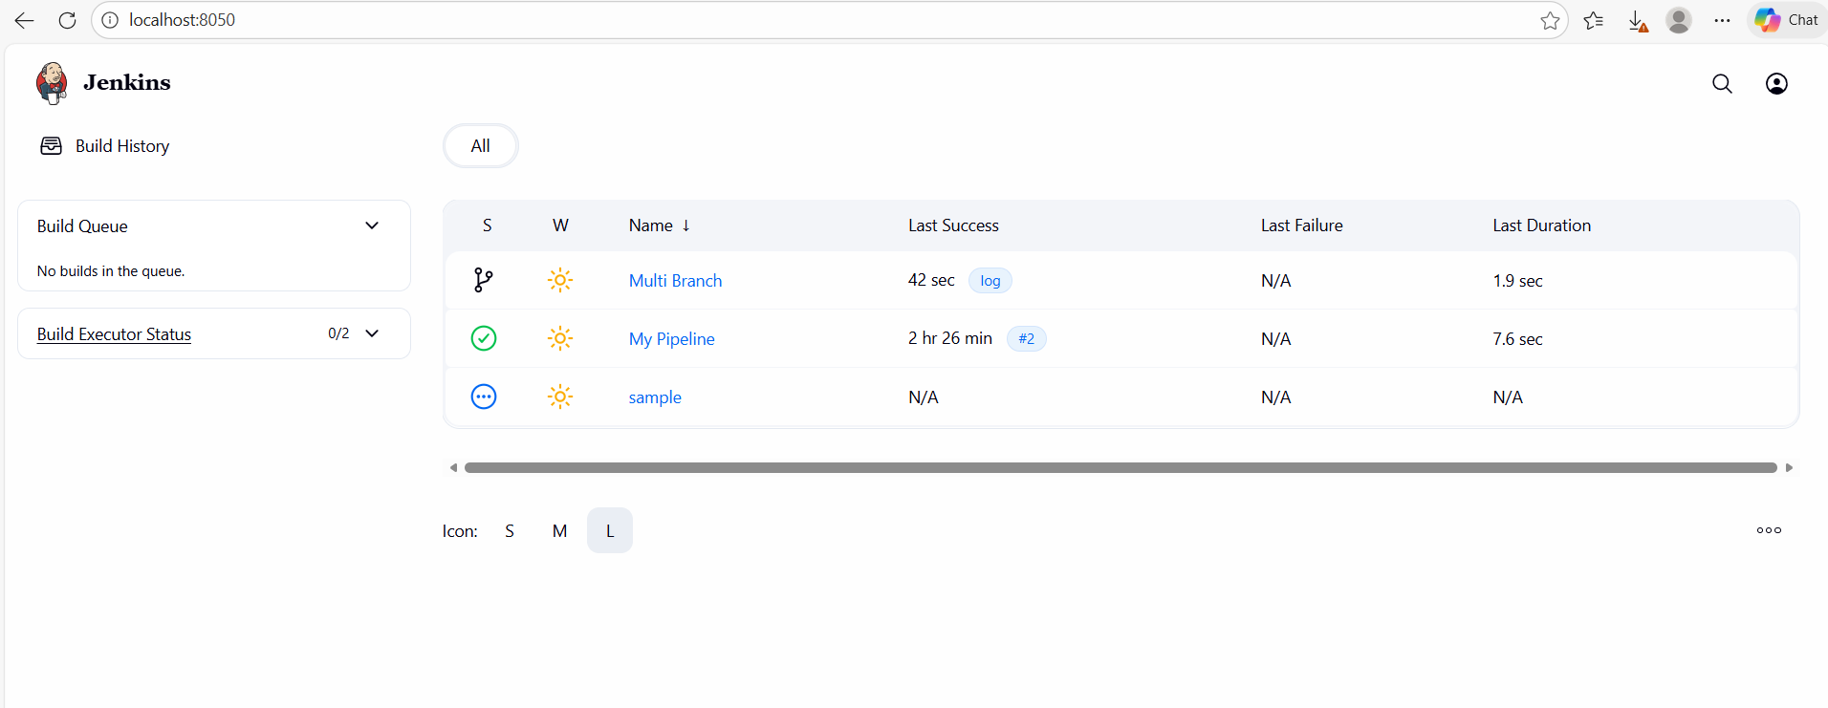
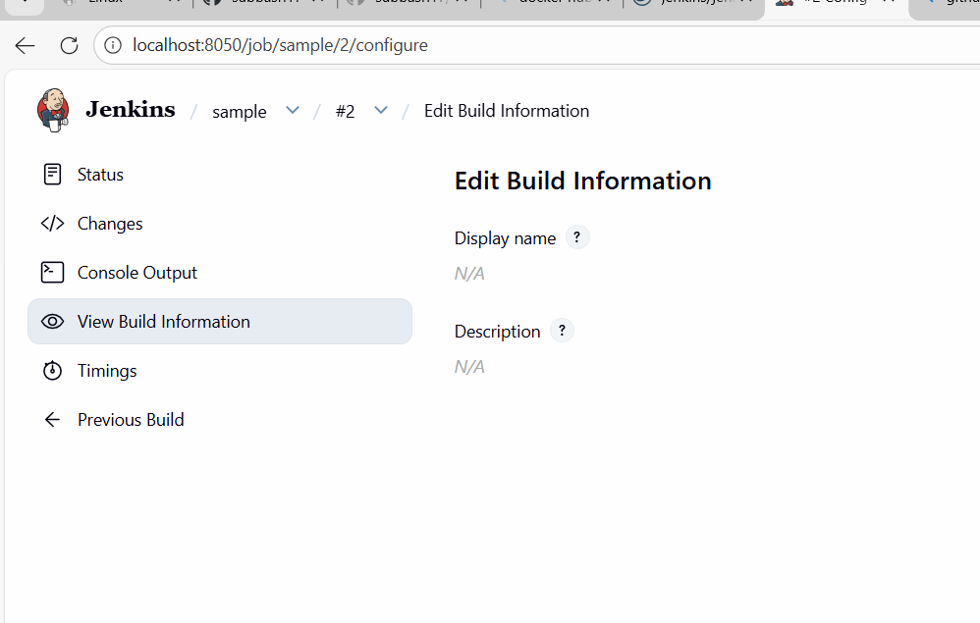

As an admin, I can build, view and delete the job.

